##### BOLLYWOOD TV

##### 15IT490L-INDUSTRIAL MODULE I PROJECT REPORT

###### ***Submitted by***

##### VIVEK MUDALIAR(RA1611008010191)

**HARSH RANJAN(RA1611008010389)**

*for the assessment of Semester V*



SRM UNIVERSITY

KATTANKULATHUR

OCTOBER 2018

**DECLARATION**

I ………………………….(Name of the Student with Reg. No.) studying in III year B.Tech Information Technology program at, SRM University, Kattankulathur, Chennai, hereby declare that this project is an original work of mine and I have not verbatim copied / duplicated any material from sources like internet or from print media, excepting some vital company information / statistics and data that is provided by the company itself.

Signature of the Student

Date:

Place:

ACKNOWLEDGEMENT

Working in good environment and motivation enhance the quality of the work we get it from our college through our project.

We have been permitted to take this golden opportunity under the expert guidance of Prof Rishiraj Purohit.

We heartily thank to them to make complete our project successfully. He has given us his full experience and extra knowledge in practical field

Vivek Mudaliar and Harsh Ranjan

ABSTRACT

The availability of low-cost mobile phones and the already broad coverage of GSM networks in Developing Countries are a huge opportunity to provide services, based on Information and Communication Technologies (ICT), that would trigger development and improve people lives. A first step in that direction has been the apparition, last two years, of numerous success stories using mobile phones in development. However, there is still a gap between the development of few services that demonstrate the proof of concept, and the availability of thousands of services in all Developing Countries of the World. This paper explores this gap, and the potential solution to fill it with the enabling of Mobile Web technologies. In a first part, this paper revisits the current technologies, mostly SMS, used in the mentioned success stories, and their abilities to scale well. In a second part, we present the strength of Web technologies, the challenges specific to this context, and the way to address them. In the last part, we introduce a potential program W3C may start to help enabling the next generation of Mobile Web applications for rural communities of the Developing World.

LIST OF FIGURES

NO NAME

1. Activity Diagram of User
2. Class Diagram of User
3. Use Case Diagram of User
4. Sequence Diagram Of User

TABLE OF CONTENTS

Acknowledgement

Abstract

List of Figures

Table of Contents

1 INTRODUCTION

* 1. Introduction
  2. Scope
  3. Project Summary
  4. Overview of Project
  5. Project Definition

1. Technology and Literature Review
   1. About Tools And Technology
   2. Brief History Of Work done
2. SYSTEM REQUIREMENTS AND STUDY
   1. User Characteristics
   2. Hardware and software requirements
   3. Constraints
      1. Regulatory Policies
      2. Hardware Limitations
      3. Interfaces to Other Applications
      4. Parallel Operations
      5. Reliability Requirements
      6. Criticality of the Application
      7. Safety and security Consideration

3.4 Assumption and Dependencies System Analysis

4.1 Study of Current System

4.2 Problem and Weaknesses of Current System

4.3 Requirements of New System

4.3.1User Requirements

4.3.2 .System Requirements

4.4 Feasibility Study

4.4.1 Does the system contribute to the overall objectives of the organization?

4.4.2 Can the system be implemented using the current technology and within the given cost and schedule constraints?

4.4.3 Can the system be integrated with other system which are already in place?

4.5 Requirements Validation (is concerned with showing that the requirements actually define the system which the customer wants)

4.6 Features of New System

4.7 Activity/Process in New System (U se event table)

4.8 Class Diagram

4.9 System Activity

* 1. Sequence Diagram

1. SYSTEM DESIGN

5.1 Database Design/Data Structure Design

1. System Testing
2. Conclusion
3. Bibliography
4. INTRODUCTION
   1. Introduction

**Mobile app development** is the act or process by which a mobile app is developed for mobile devices, such as personal digital assistants, enterprise digital assistants or mobile phones. These applications can be pre-installed on phones during manufacturing platforms, or delivered as web applications using server-side or client-side processing (e.g., JavaScript) to provide an "application-like" experience within a Web browser. Application software developers also must consider a long array of screen sizes, hardware specifications, and configurations because of intense competition in mobile software and changes within each of the platforms. Mobile app development has been steadily growing, in revenues and jobs created. A 2013 analyst report estimates there are 529,000 direct *app economy* jobs within the EU 28 members, 60% of which are mobile app developers.[0](https://en.wikipedia.org/wiki/Mobile_app_development#cite_note-1)

As part of the development process, mobile user interface (UI) design is also essential in the creation of mobile apps. Mobile UI considers constraints, contexts, screen, input, and mobility as outlines for design. The user is often the focus of interaction with their device, and the interface entails components of both hardware and software. User input allows for the users to manipulate a system, and device's output allows the system to indicate the effects of the users' manipulation. Mobile UI design constraints include limited attention and form factors, such as a mobile device's screen size for a user's hand(s). Mobile UI contexts signal cues from user activity, such as location and scheduling that can be shown from user interactions within a mobile app. Overall, mobile UI design's goal is mainly for an understandable, user-friendly interface. The UI of mobile apps should: consider users' limited attention, minimize keystrokes, and be task-oriented with a minimum set of functions. This functionality is supported by mobile enterprise application platforms or integrated development environments (IDEs).

Mobile UIs, or front-ends, rely on mobile back-ends to support access to enterprise systems. The mobile back-end facilitates data routing, security, authentication, authorization, working off-line, and service orchestration. This functionality is supported by a mix of middleware components including mobile app server, mobile backend as a service (MBaaS), and service-oriented architecture (SOA) infrastructure.

* 1. SCOPE

This application will allow the user to browse through and search for a particular movie and then will allow the user to read the specifics and the user can download the movie.

* 1. SUMMARY

Bolly TV is an android application which will allow the user to browse and select the movie which they want and read the ratings, description, genre etc. And is one is willing to watch the specific movie they will be given a direct download link for the movie so the user can download the movie.

* 1. OVERVIEW OF PROJECT

Bolly TV will ask the user to login as the application is opened and if the user is opening the application for the first time they will have to signup in which they need to enter their Name, Last Name, Email id, Password and then they can login.

Once the use is logged in the android application which will allow the user to browse and select the movie which they want and read the ratings, description, genre etc. And is one is willing to watch the specific movie they will be given a direct download link for the movie so the user can download the movie.

* 1. PROJECT DEFINATION

Bolly TV is an android application which will allow the user to browse and select the movie which they want and read the ratings, description, genre etc. And is one is willing to watch the specific movie they will be given a direct download link for the movie so the user can download the movie.

1. TECHNOLOGY AND LITERATURE REVIEW

2.1 Tools and Technology

2.1.1 Android Studio

**Android Studio** is the official integrated development environment (IDE) for Google's Android operating system, built on JetBrains' IDEA software and designed specifically for development. It is available for download on Windows, macOS and Linux based operating systems. It is a replacement for the Eclipse Android Development Tools (ADT) as primary IDE for native Android application development.

Android Studio was announced on May 16, 2013 at the Google I/O conference. It was in early access preview stage starting from version 0.1 in May 2013, then entered beta stage starting from version 0.8 which was released in June 2014.[10](https://en.wikipedia.org/wiki/Android_Studio#cite_note-11) The first stable build was released in December 2014, starting from version 1.0. The current stable version is 3.1.3 released in June 2018.

2.1.2 Firebase

Firebase evolved from Envolve, a prior startup founded by James Tamplin and Andrew Lee in 2011. Envolve provided developers an API that enables the integration of online chat functionality into their websites. After releasing the chat service, Tamplin and Lee found that it was being used to pass application data that weren't chat messages. Developers were using Envolve to sync application data such as game state in real time across their users. Tamplin and Lee decided to separate the chat system and the real-time architecture that powered it. They founded Firebase as a separate company in April 2012.

* + 1. BRIEF HISTORY OF WORK DONE

|  |  |
| --- | --- |
| Milestones | Deliverables |
| Study about android application requirement and planning | Analysis Report |
| Understand a project definitions and basic terms and logic for Parameter | Analysis Report |
| Gathering requirements of the project using different fact finding techniques | SRS |
| System Design including various diagrams | SRS |

1. SYSTEM REQUIREMENTS STUDY

Analysing user characteristics is an important aspect of any project. It allows us to clearly define and focus on who the end users are for the project. Also, it allows checking the progress of the project to ensure that we are still developing the system for the end users. The user must have the following characteristics:

* User must have basic knowledge of Computers.
* User should understand the use of all modules.
* User can easily interact with the proposed system.
* User must know the technical terms used in the company for performing different tasks.
* User should be also being aware about the running process of the system.

FUNCTIONALITY OF PROPOSED SYSTEM

USER:-

* Signup
* Login
* Change password
* Forgot Password
* View the movie list
* Select the movie
* View the description
* Download the movie
  1. HARDWARE AND SOFTWARE REQUIREMENTS
     1. **Software Requirements**

Server

* Database server: Firebase
* Development tools :Android Studio
  + 1. **Hardware Requirements**
* 500 MB of Ram
* Android system
* Internet Connection
* Android version 4.3 and above

**3.3 CONSTRAINT**

3.3.1 Regulatory Policies

Regulatory policies about achieving organization’s objectives through the use of regulations, laws, and other instruments to deliver better economic and social outcomes and thus enhance the life of business. Thus the system should be developed by using these regulations to provide better outcome to the company.

3.3.2 Hardware Limitations

Hardware Limitations are other constraint of the system. Hardware Limitations should be overcome for better performance of the system. This can be achieved by using minimum and only necessary hardware.

3.3.3 Interfaces to Other Applications

Like classes or structures, interfaces too can be defined In terms of generic type parameters. Generic interfaces provide all the benefits of interface-based programming without compromising type safety, performance, or productivity.

3.3.4 Parallel Operations

The project is on basis of multi-user. This is used for carrying out updating as well as entry by preventing the redundancy of the data.

3.3.5 Reliability Requirements

Reliability requirements of the system are one of the prime ones in the list. The system is needed to be highly reliable in terms of performance and capable of delivering robust performance. If the reports are generated within 5 seconds, then the system is said to be reliable.

3.3.6 Criticality of the Application

The system can stop working on computers with very low internet connection. Other than that there won’t be any issues. Apart from these the system should be able to make updates at regular time intervals.

3.3.7 Safety and Security Consideration

Safety and security too are other major concerns of any system. It is necessary to provide safety and security as the system is web application and might be intrude by security threats the interest. Thus, the code needs to be encrypted and any transaction needs to be done securely. '

3.4 ASSUMPTION AND DEPENDENCIES

3.4.1 Assumptions

Database transactions are assumed to be secure and reliable. User is the person having enough knowledge for the traversing operation. We will provide a user friendly interface so that any user can easily navigate through the system, but he/she should be capable of providing valid credentials for successful login. . The server used for data storing is always secured. 3.4.2 Dependencies

The system is dependent upon the user’s valid credentials. If user inputs wrong username or password, he/she will not be allowed to login to the system. 0 This application depends on the server and internet as all the information is collected and then stored in the server through secure internet connection. 0 All the users of the system will be assigned a specific role. According to these roles and every user will be allowed to access predefined set of feature.

4 SYSTEM ANALYSIS

4.1 STUDY OF CURRENT SYSTEM

The manage user, manage whole system, manages by admin.

Manual systems are very difficult to manage.

It is time consuming.

It is most difficult for report generation.

4.2 PROBLEM AND WEAKNESS OF CURRENT SYSTEM

> There is no communication.

> Users have to login every time to get upgraded with the latest auction bid on product.

> The ability to communicate with all other users.

4.3 REQUIREMENTS OF NEW SYSTEM

4.3.1 USER REQUIREMENTS

4.3.1.1 Performance:

This system should remain accessible 24x7. At least IOO users should be able to access the system altogether at any given time.

4.3.1.2 Security:

The database of system should not store any password in plain text rather the cease: cipher text has to be stored.

* + - 1. Reliability:

It can be accessed by the end users 24"7 as an when needed hence is highly reliable for end users.

* + - 1. Availability: Internet connection for the nodes with the database server is ensured and hence the application will be available any time for access.

4.3.1.5 Portability: The developed web application is portable s it can be accessed from any operatic: system regardless Windows, Mac, Linux provided they have a browser to access Internet.

* + 1. SYSTEM REQUIREMENTS

Memory

Networking

Platform Independent

Backup

Update

4.4 FEASIBLITY STUDY

An important outcome of the preliminary investigation is the determination that the m requested is feasible. The feasibility study is carried out to examine the likelihood that the system will be useful to the organization.

There are four aspects in the feasibility study namely.

> Operational Feasibility > Technical Feasibility > Economic Feasibility

4.4.1 Technical Feasibility: The main purpose of checking Technical Feasibility is to examine whether the current technology is sufficient for the development of the system. So, this application is Technically Feasible.

4.4.2 Operational Feasibility:

The main purpose of checking Operational Feasibility is to find out whether the system will be functional alter its development and installation or not.

The outcomes of the Operational feasibility are as follows:

> This application provides of all the user that the user can easily sell their product or easily buy their product.

> This application is less time consuming. So, this application is operationally feasible.

4.4.3 Economic Feasibility: The main purpose of checking Economical Feasibility is to examine whether the financial investment in the system will meet the organization’s requirements or not.

The outcomes of the technical feasibility are as follows:

> The advantages of the system nullify its development cost as the scope and effect of the system are very large. So, this application is economically feasible.

4.5 REQUIREMENTS VALIDATION

The Basic validation from user side is to detect wrong information or blank information: When the user has entered correct username and password, then he/she is allowed to enter information or to see the information either into the database or from the database. If anyone field from username or password remains blank, then user will not be allowed to authenticate of this system. If user has entered wrong data like password, then it will message generate.

1. SYSTEM DESIGN

5.1 Database Design/Data Structure Design

|  |  |  |  |
| --- | --- | --- | --- |
| Field Name | Data Type | Constraint | Description |
| FirstName | String | Not Null | This will be used for storing the first name. |
| LastName | String | Not Null | This will be used for storing the last name. |
| Email id | String | Not Null | This will be used to store the email id. |
| Password | String | Not Null | This will be used to store the password. |
| Confirm Password | String | Not Null | This will be used use to compare the password string. |

CLASS DIAGRAM

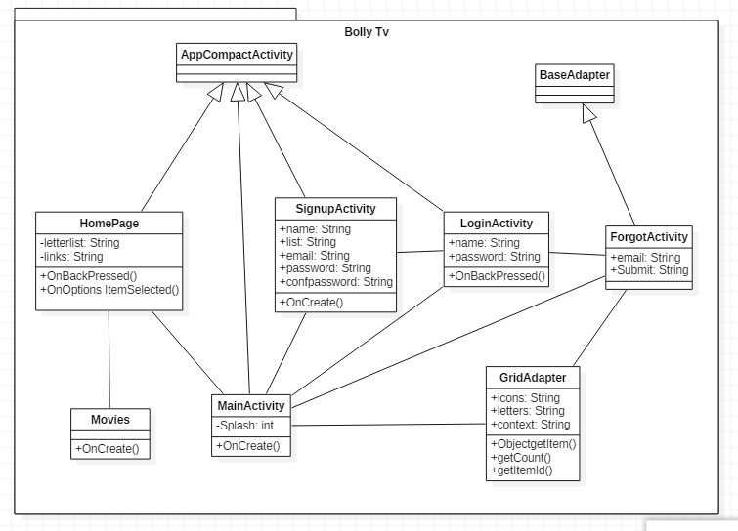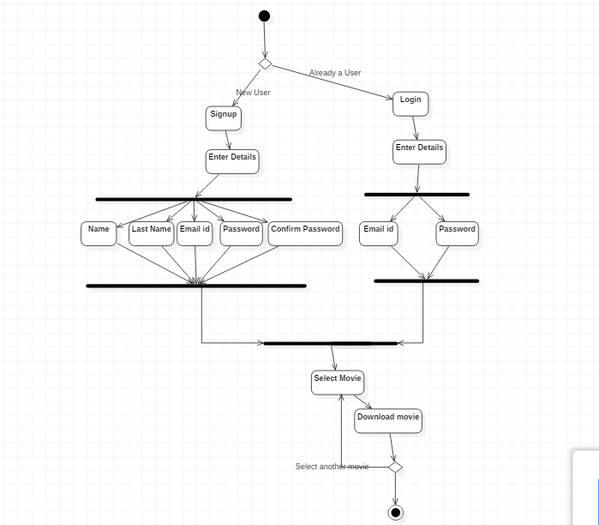

ACTIVITY DIAGRAM

USE CASE DIAGRAM

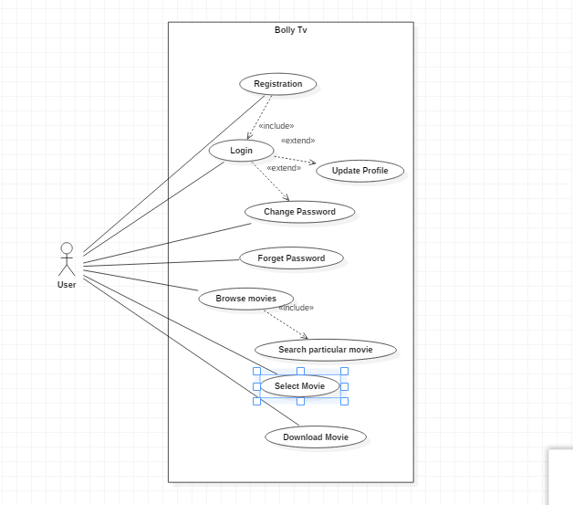

SEQUENCE DIAGRAM

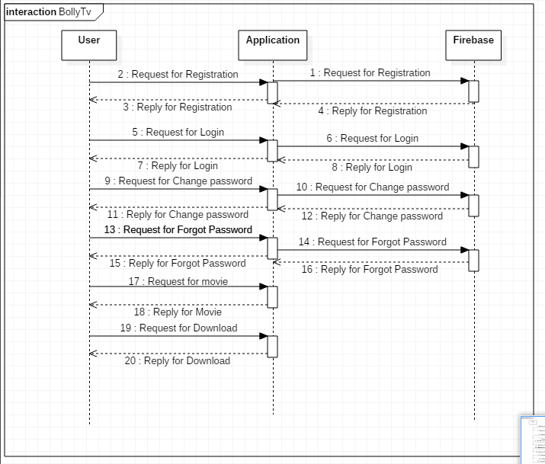6 SYSTEM TESTING

|  |  |
| --- | --- |
| TEST CASE | SIGNUP |
| Purpose | When the user login they enter name, lastname, userID and Password. |
| Input | UserID, Password, name lastname, confirm password |
| Expected Output | Authentication of system |

|  |
| --- |
| Steps:  1. Enter the user ID, Password, name, lastname, confirm password.  2. User authenticate the System. |

|  |  |
| --- | --- |
| TEST CASE | LOGIN |
| Purpose | When the user login they enter userID and Password. |
| Input | UserID, Password |
| Expected Output | Authentication of system |
| Steps:  1.Enter the UserId,Password  2. User authenticate the System. |

`



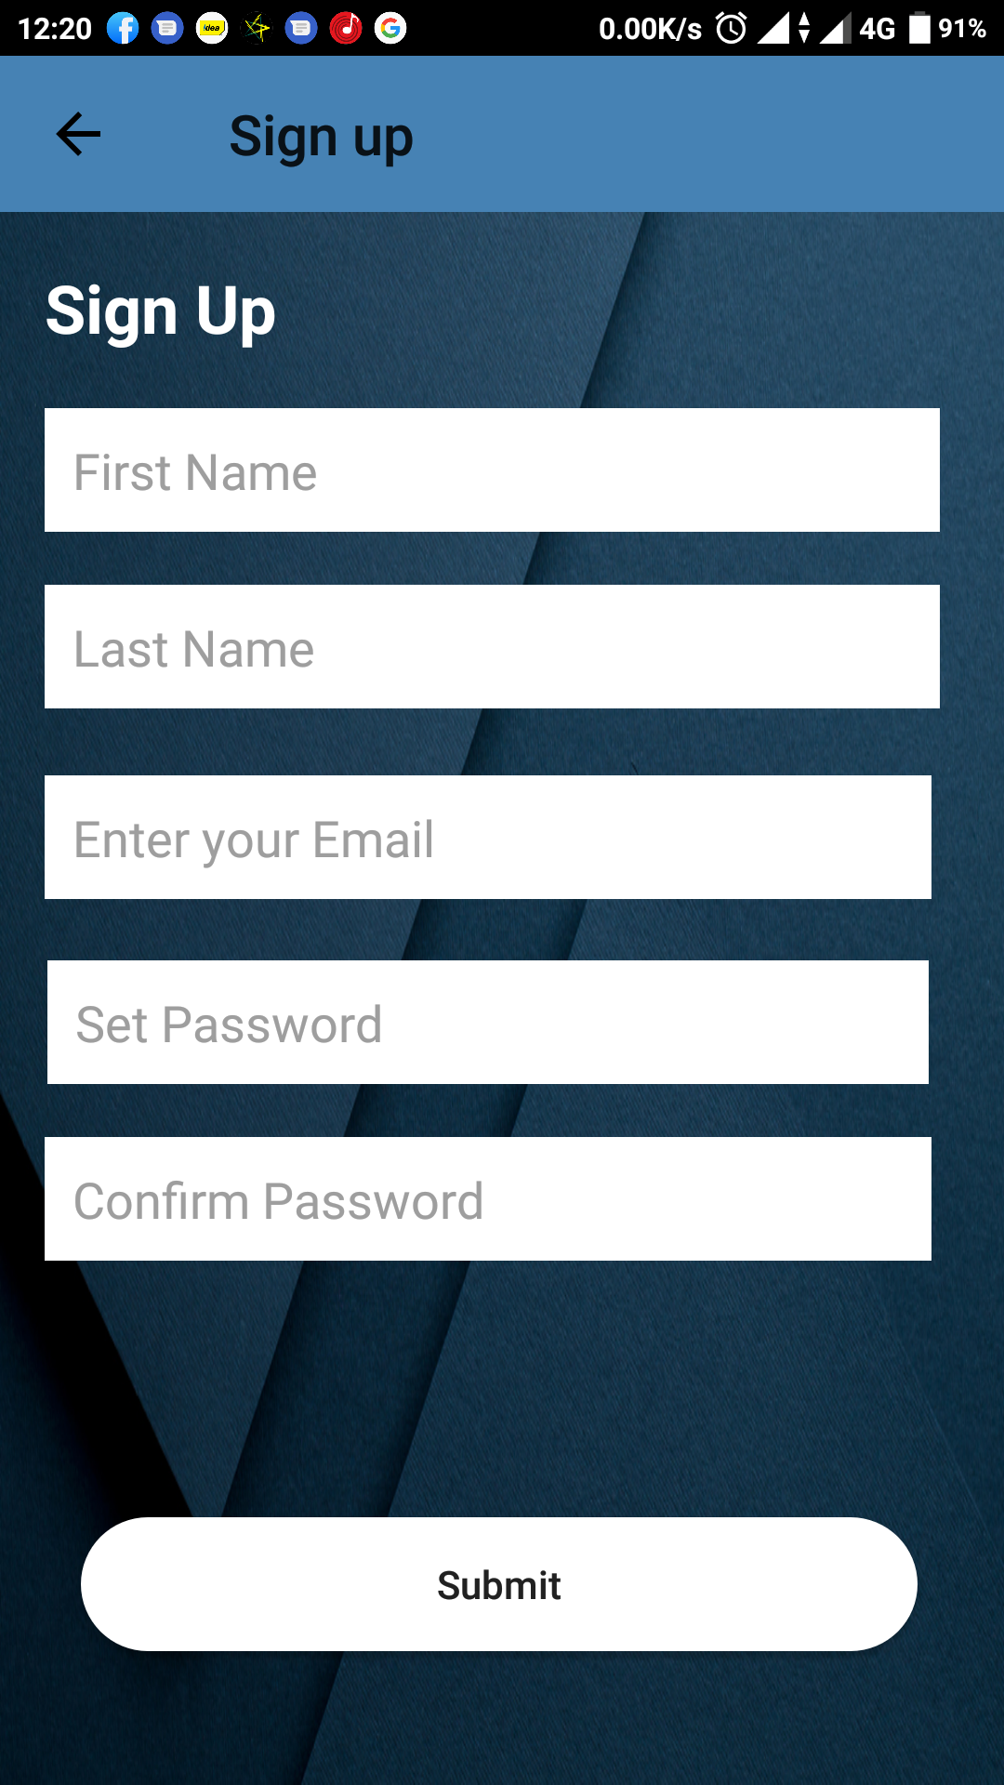

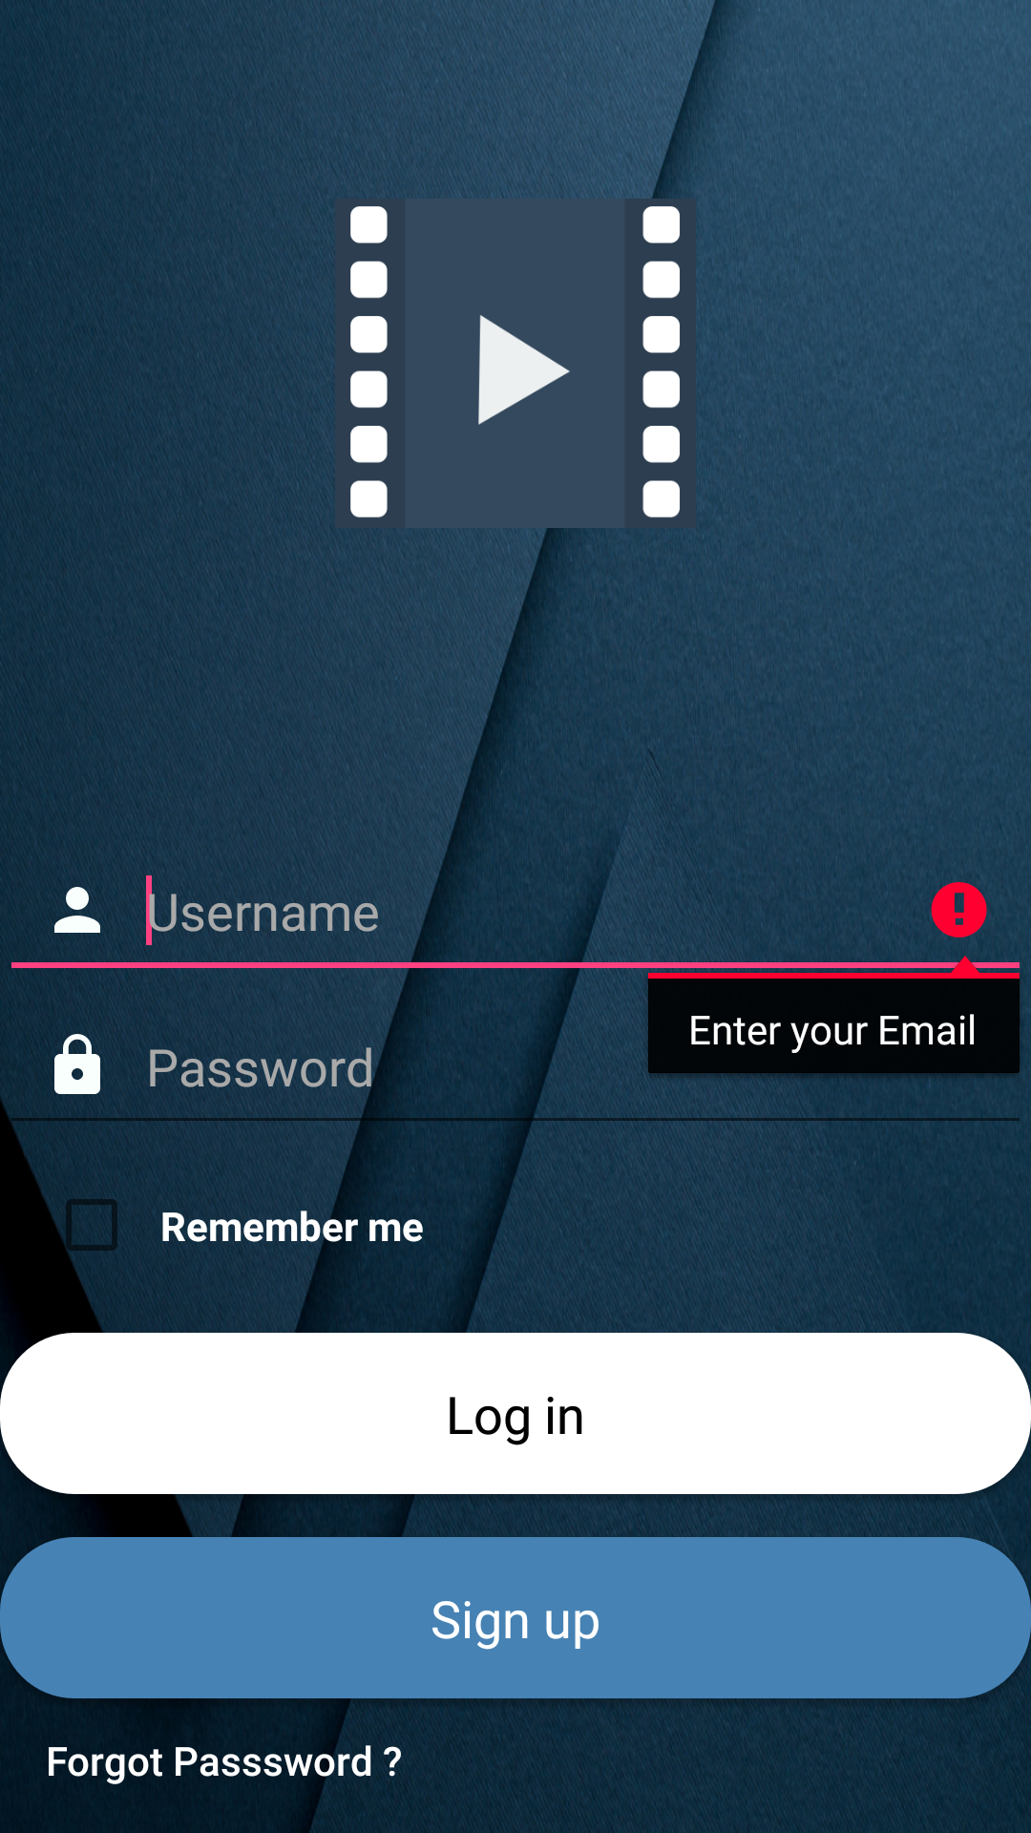

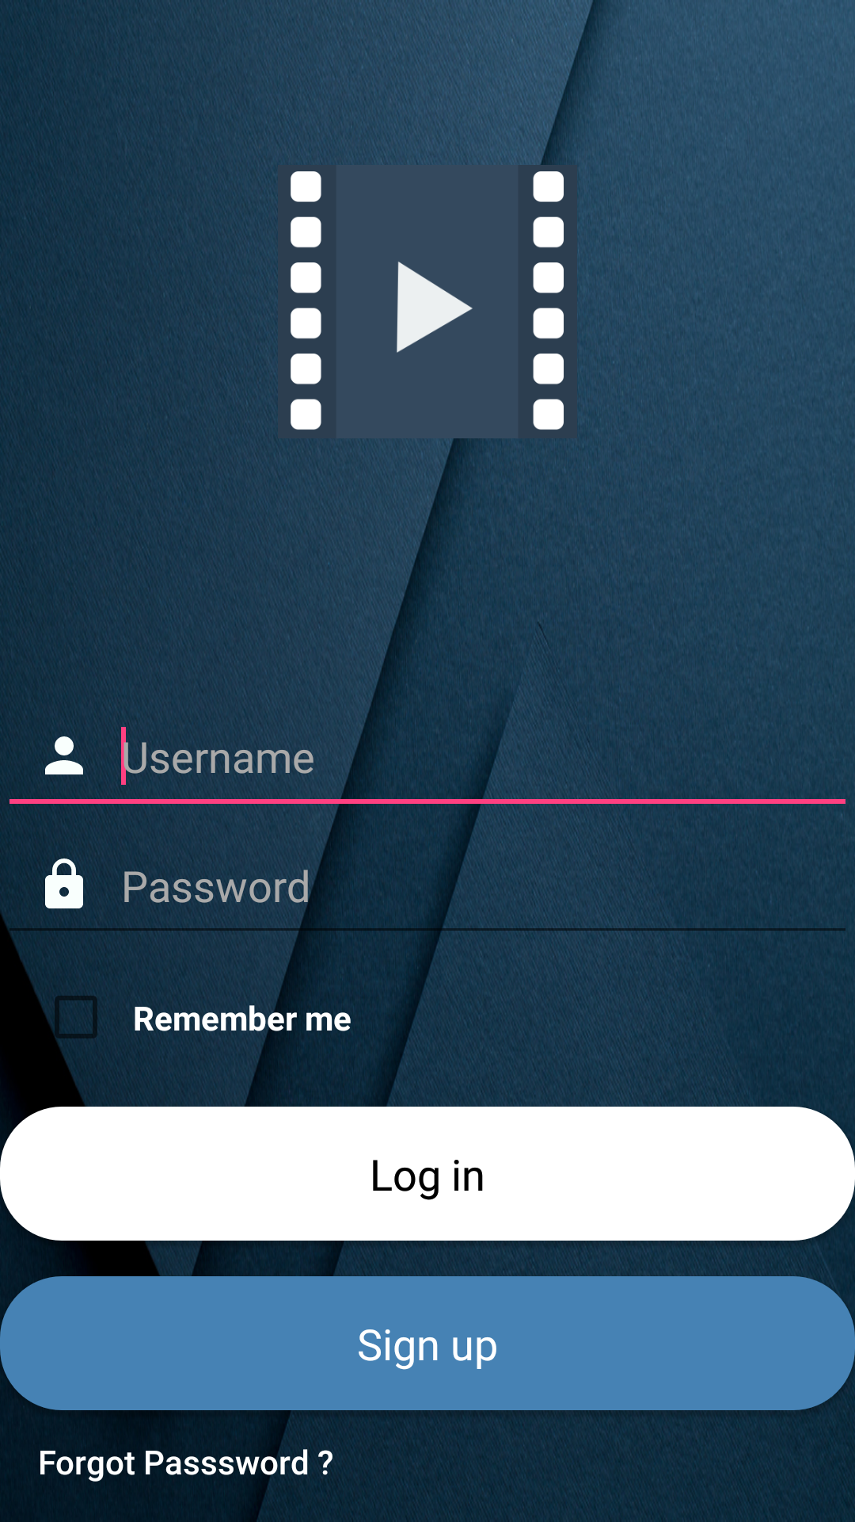

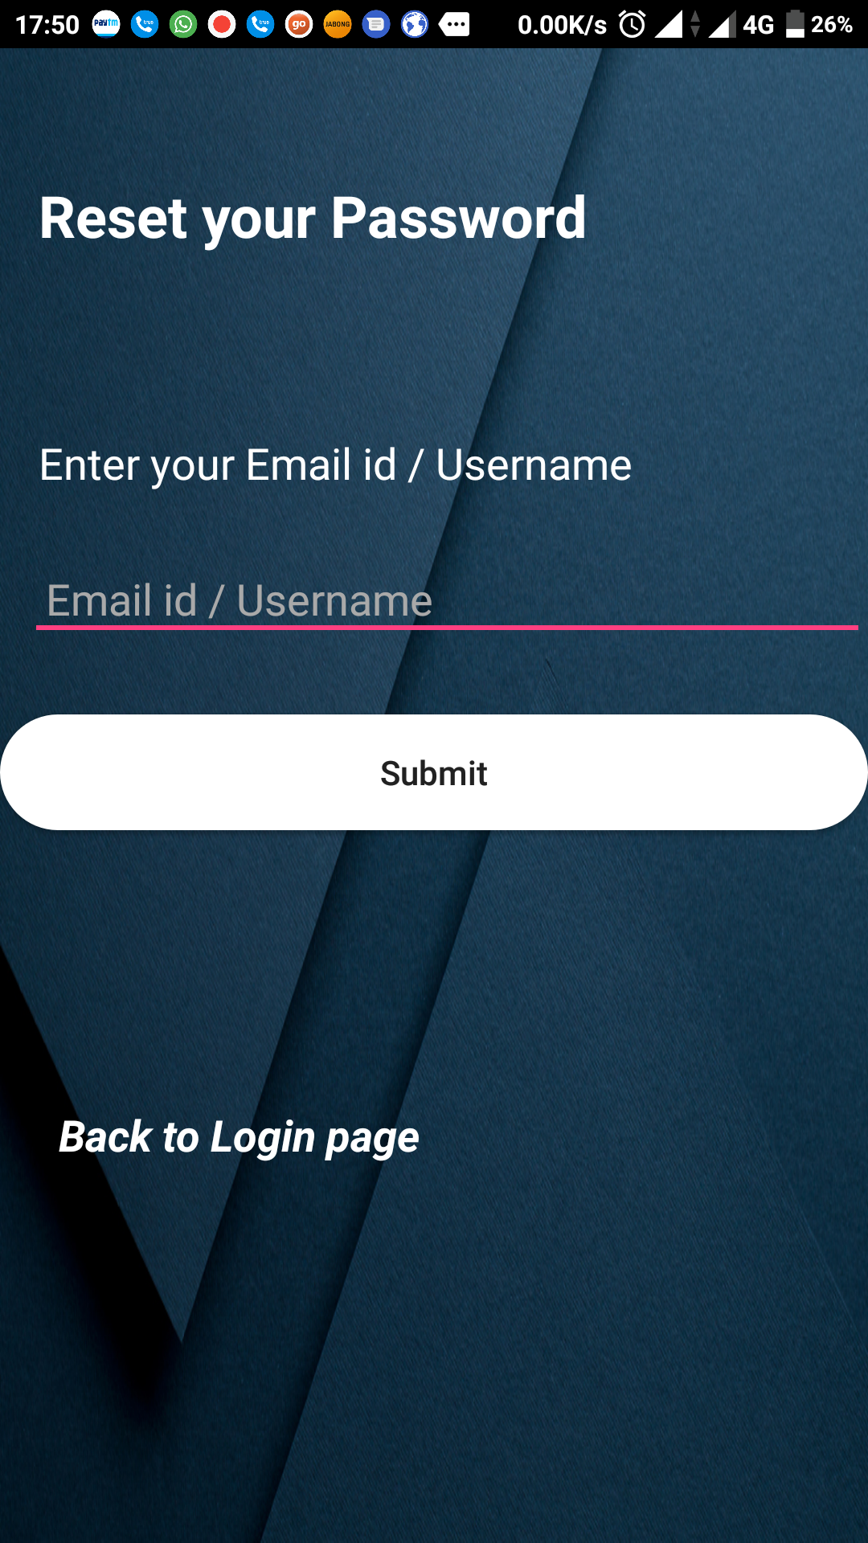

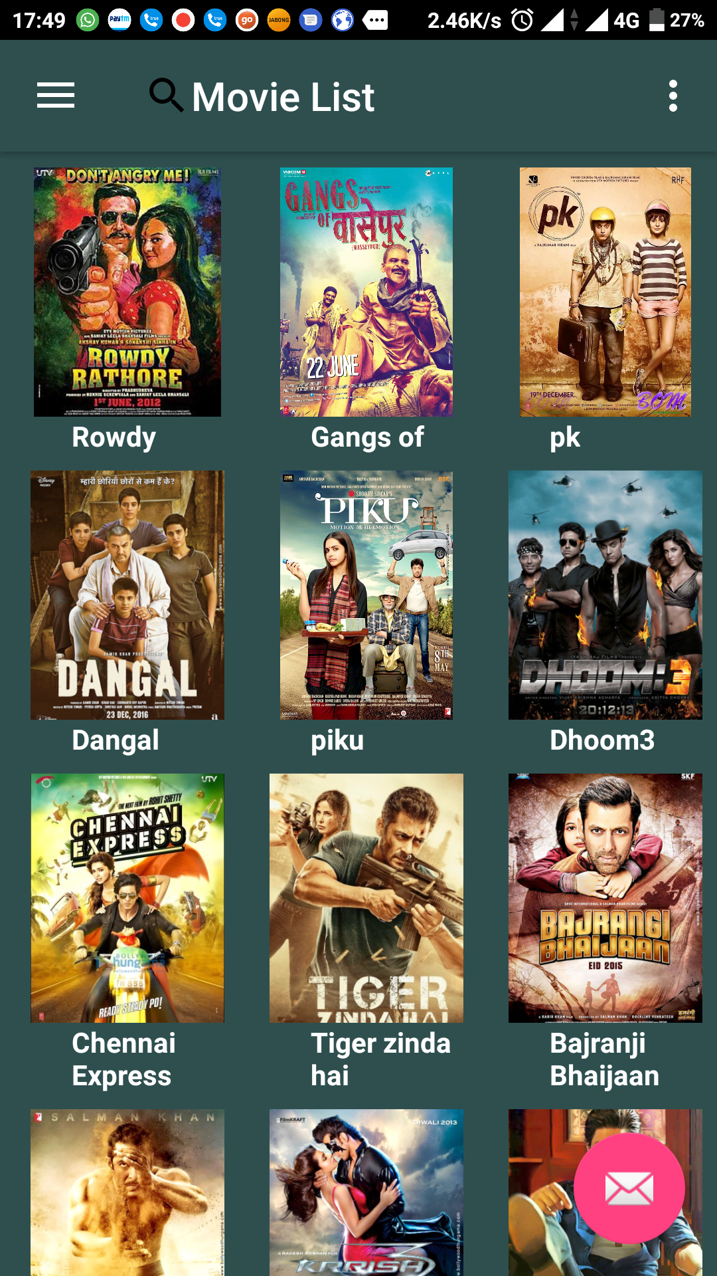

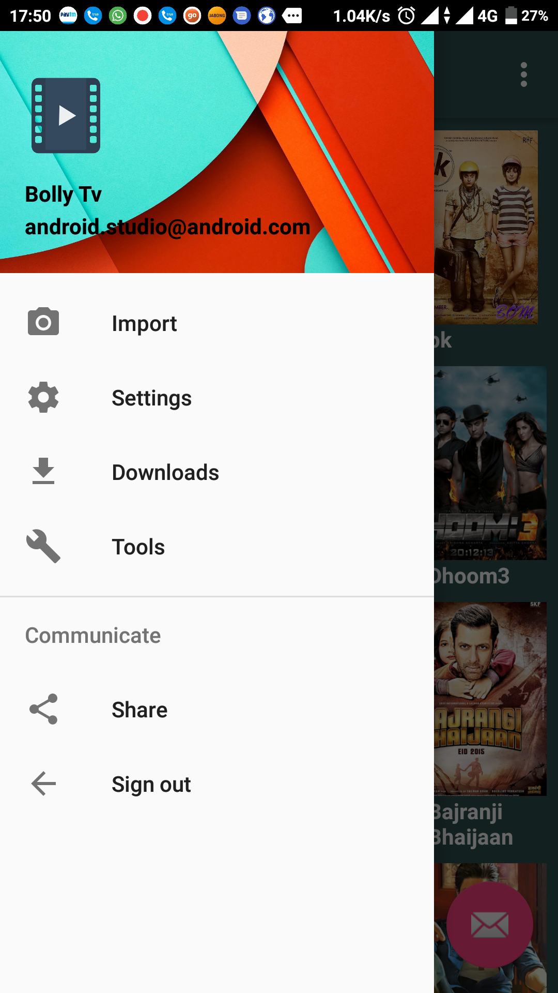

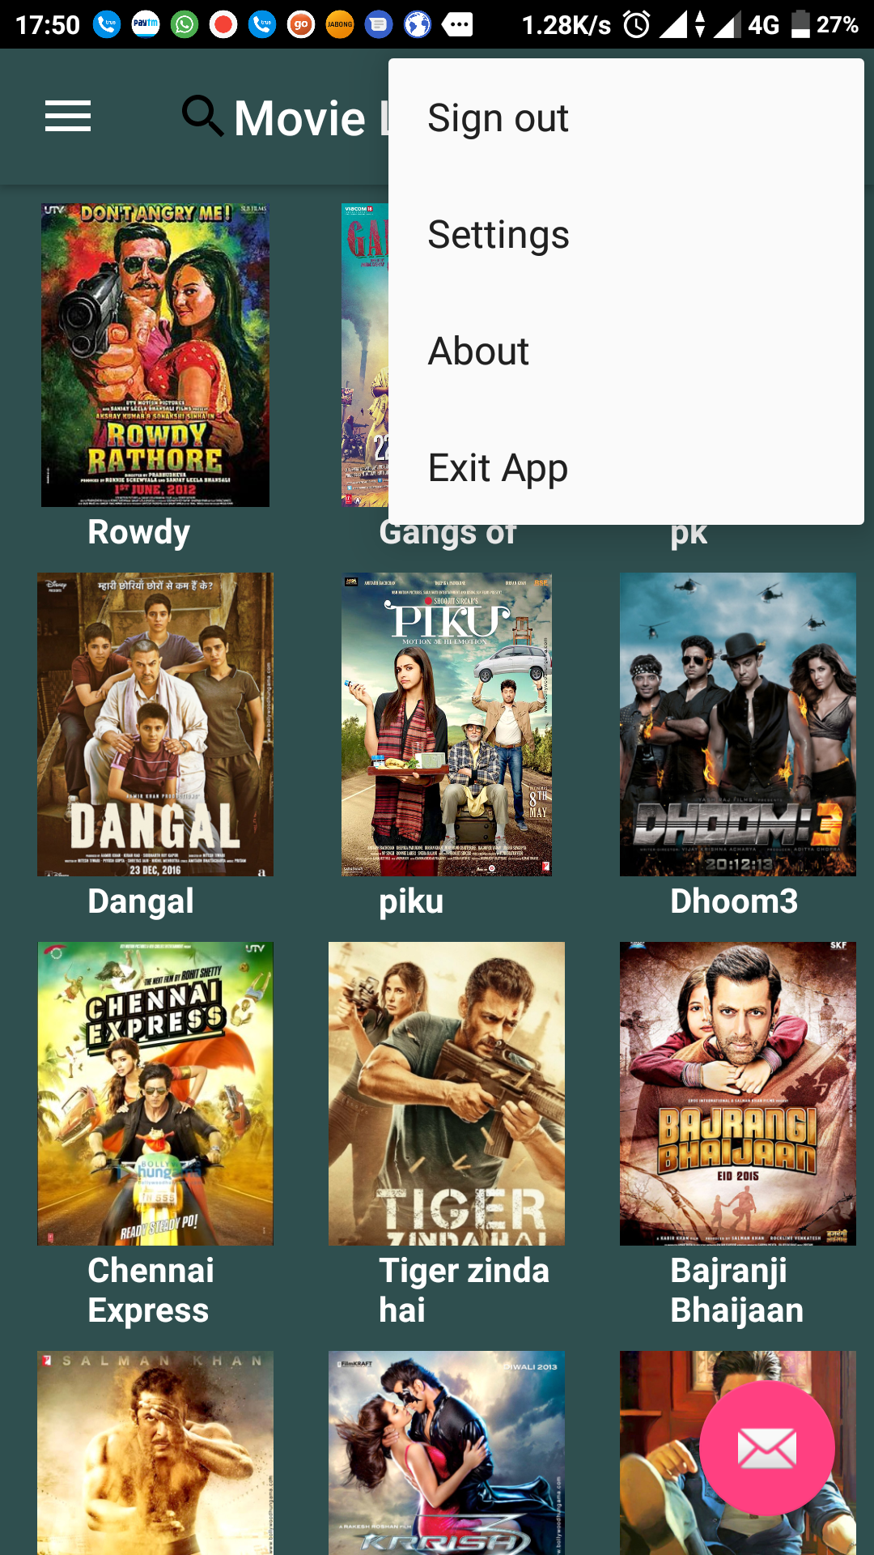

1. FUTURE ENHANCEMENT

* In this project we can add paid movies.
* User can get the notification by SMS.
* We can use Artificial Intelligence.
* We can develop this project for IOS, Microsoft systems.

1. CONCLUSION

This android will help the user to browse through the movie list and also search for a particular movie and then reading its description such as rating, genre, plot summary etc.

Then as per the users which they can download the movie or continue browsing through the available list.

1. BIBLOGRAPHY

* [developer.android.com](https://developer.android.com)
* Stackoverflow.com